Registration Form

**The 7th International Conference on Advanced Communication Technologies and Networking (CommNet 2024).**

* Participant*: Mr. or Ms
* Full name*:__________________________________________________
* *Category: Author: ▭ Author (Low and lower-middle income country)▭ Student author (Low and lower-middle income country)▭ Non-Author/**#**Co-author ▭
* Presenter’s Full name*:________________________________________
* Paper(s)’ ID(s)*:____________________
* Registration type*: **Ordinary-Early bird fees** ▭ **Ordinary-Late registration fees** ▭
* Wire transfer date*: _____________________
* Non-author*:
  + Institute/Company:__________________________________________________
  + Country:______________________________
  + E-mail:________________________________

**Registration fees:**

Please specify your choice from the table below

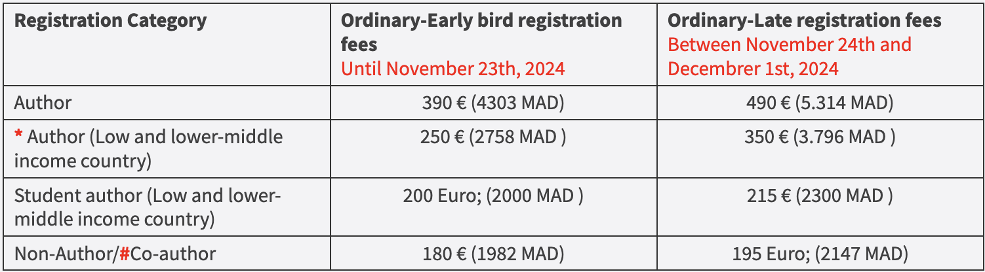

**\*** To identify if The affiliations’ country is a low or lower-middle income country, check tables "LOW-INCOME ECONOMIES" and "LOWER-MIDDLE-INCOME ECONOMIES" on this link : <https://datahelpdesk.worldbank.org/knowledgebase/articles/906519-world-bank-country-and-lending-groups>

**#** Both the author and co-author are wishing to attend the conference.

**\*\*** The Non-student Author must be the first author of the paper, is from a low or lower-middle country and is **UNEMPLOYED**. This registration covers only one accepted paper  
**\*\*\*** The student must be the first author of the paper, and is from a low or lower-middle country. **Only UNEMPLOYED students are eligible for such a rate**. This registration covers only one accepted paper.  
**\*\*\*\*** The author must be the **first author** in his paper.

**Important:**

* **Each Author/co-Author wishing to attend the conference must be registered.**
* **The above fees do not cover any wire transfer cost.**
* **Extra additional page**: 25 Euros per extra additional page above the 7th page (i.e., papers with a number of pages greater or equal 8 are subject to extra page charges)
* One registration is valid **ONLY**for one person.

**One Ordinary Registration for participants includes:**

* **Registering  one paper,**
* **Access to Keynote Talks**
* **Access to Paper/Tutorial Presentations**
* **Coffee and refreshment breaks (on the conference facilities)**
* **Lunches on 4, 5 and 6 of December 2024**
* **A program book of the conference**
* **Electronic conference e-Proceedings**
* **Participation Certificate**

Please return the first page of this Registration form filled and a copy of your bank transfer receipt by e-mail to [ayoubfouadn@gmail.com](mailto:ayoubfouadn@gmail.com). The paper EDAS # should be indicated in the subject of e-mail.

* Authors willing to register should indicate the presenter’s First and last name, if they are not the presenters of their accepted papers. **Leaving the presenter’s full name field in blank means that the registrant is himself the presenter.**
* Students should send a proof of their full-time student status and **unemployment certificate.**

**CONTACT:**

***For any questions or concerns, please feel free to contact us at ayoubfouadn@gmail.com, f.elbouanani@um5s.net.ma.***